Chapter 10: What Can We Learn from Baduy People?


Tujuh Pembelajaran:

Setelah mempelajari Bab 10, siswa diharapkan mampu:

- Mensyukuri kesempatan dapat mempelajari bahasa Inggris sebagai bahasa pengantar komunikasi International yang diwujudkan dalam semangat belajar.

2.1 Menunjukkan perilaku santun dan peduli dalam melaksanakan komunikasi interpersonal dengan guru dan teman.

2.2 Menunjukkan perilaku jujur, disiplin, percaya diri, dan bertanggung jawab dalam melaksanakan komunikasi transaksional dengan guru dan teman.

2.3 Menunjukkan perilaku tanggung jawab, peduli, kerjasama, dan cinta damai, dalam melaksanakan komunikasi fungsional.

3.6 Menganalisis fungsi sosial, struktur teks, dan unsur kebahasaan pada teks ilmiah berbentuk factual report tentang binatang.

4.9 Menangkap makna dalam teks ilmiah faktual (factual report) lisan dan tulis tentang binatang.

4.10 Menyusun teks ilmiah faktual (factual report) lisan dan tulis tentang binatang dengan memperhatikan fungsi sosial, struktur teks, dan unsur kebahasaan yang benar sesuai konteks.


Bahasa Inggris | 147

A. WARMER: GUESSING GAME
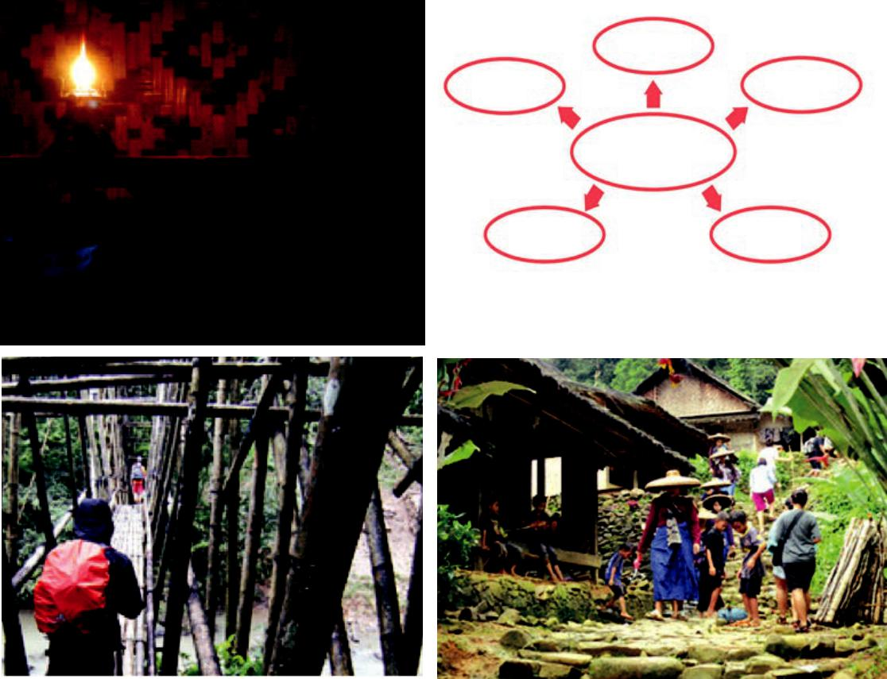

Sources:
  - http://discoveryourindonesia.com/wp-contents/uploads/2014/01/night-in-baduy.jpg B.http://discoveryourindonesia.com/wp-contents/uploads/2013/03/suku-baduy.jpg C.http://discoveryourindonesia.com/wp-contents/uploads/2013/03/Baduy.jpg D.http://discoveryourindonesia.com/wp-contents/uploads/2014/01/people-in-baduy.jpg Picture 10.1-4 Baduy Tribe

- OBSERVING AND QUESTIONING

Reading

Task 1: Think about it.

Before you read the following text about Baduy people, talk about these things in small groups.
- Do you know anything about Baduy people?

- Where do they live?

- What are their characteristics?

- How do they live in their community?


- Kelas XII SMA/MA/SMK/MAK

Task 2: Read the text below carefully, and then answer the questions that follow.

Little more than three hours away from Jakarta there is a traditional community that has turned their back away from modern technology. They don’t own phones, use the Internet, wear shoes or listen to the radio. Living in voluntary isolation, they are a secretive group who turn away outsiders. This group lives close to the city of Banten and they are known as the Baduy people.

Generally, the Baduy are divided into two groups: the Baduy Dalam and the Baduy Luar. The Baduy Luar act as a buffer zone to stop visitors from entering the Sacred Inner circle, the Baduy Dalam. Even though both groups are barefoot, it is so easy to differentiate them. Baduy Dalam wear white and black cloth as clothing, meanwhile Baduy Luar wear black and other colors of clothing just like us. Some people say that the black cloth the Baduy Luar people wear is an indication that they are not pure anymore, that they are breaking some rules of the community, such as their willingness to accept modern influence into their daily lives.

Right after we go into the outermost village of Baduy called Kaduketu, we can sense a different atmosphere straight away. We can see middle-aged women walking around with a log over their shoulder and kids chasing each other with big smiles on their face. Traditional Baduy houses in Kaduketu are made of bamboo that is bound with rattan wood. It is impossible to find a concrete house inside Baduy territory.

With many great views and fresh air, Baduy offers a lot of things for us to explore. You can take a bath down the river or simply walk around, observing the interesting Baduy’s daily life. The Baduy relies on farming to meet their daily needs. During harvest season, they will keep their paddy into the barn


Bahasa Inggris | 149

(Compiled and adapted from: http://discoveryourindonesia.
that is called ‘leuit’. Leuit is usually located quite far from the settlement, keeping the paddy safe if any disaster happens in their living space.

Electronic devices are banned inside Baduy Dalam. Hence, it is prohibited to take photographs. “There are lots of stories about tourists who forced to take a shot but they were followed by bad lucks afterwards. Their camera fell down the hill or into the river,” said Jaka, a Baduy Luar native.

If we’re thinking about what to do when we come here, then we need not worry because there are lots on offer, like enjoying the true relaxing times and the feeling of being isolated from modern technology and man-made things. One favorite thing to do might be observing communal life in the settlement. It is a very relaxing experience and sometimes visitors find themselves missing the simplicity and beauty of

the place.

com/baduy/ and http://www.globalindonesianvoices.com/11598/ baduy-travel/)

- What is the traditional community referred to in paragraph one?
- What are the characteristics of this traditional community?

- What is the similarity between people in Baduy Dalam and Baduy Luar?
- What are the differences between people in Baduy Dalam and Baduy Luar?
- What is the different atmosphere that you can sense when you enter Kaduketu?
- Is it possible to find concrete houses in Kaduketu? Why?

- What can you explore in Baduy?

- What is ‘leuit’?

- Kelas XII SMA/MA/SMK/MAK

- Are visitors allowed to take photographs in Baduy Dalam? Why?
- What are the writer’s favorite activities when she visits Baduy?

Vocabulary Builder

Task 3: Find the meaning of words.

After reading the text about Baduy people, individually guess the meaning of each word below. Then, check them with your friends. When necessary, consult your dictionary. After that, practice pronouncing the words.

v o l u n t a r y : /ˈ vɑːlənteri/

t u r n a w a y : / tɜːrnəˈ weɪ /

s a c r e d : / ˈ seɪkrɪd/

b a r e f o o t : /ˈ berfʊt/

i n d i c a t i o n : /ˌ ɪndɪˈ keɪʃə n /

r e l y o n : / rɪˈ laɪɒː n/

b a r n : / bɑːrn/

s e t t l e m e n t : / ˈ setlmənt/

b a n n e d : / bænd/

i s o l a t e d : /ˈ aɪsəleɪtɪd/

Grammar Review

Task 4: Observe the noun phrases.

Look through the text again. Can you find noun phrases? Noun Phrase is a word or a group of words in a sentence that function as a noun, for example pay attention to the words in the italic forms at the sentence below:

Little more than three hours away from Jakarta there is a traditional community that has turned their back away from modern technology.

Bahasa Inggris | 151

Underline some other noun phrases in the text. Do you know what words make up noun phrases, adjective + noun, adverb + noun, or noun + noun? Discuss with your friends.

Text Structure

Task 5: Observe the text structure.

The text about Baduy people above is called a factual report (information report). A factual report aims to provide information about natural or social phenomena. In this case, the text provides information about Baduy people.

How are factual reports written? The first paragraph of a

factual report gives us a classification containing some general information about the phenomena, that is, the Baduy people (i.e. description of the general characteristics of the people and where

we can find them). All the paragraphs that follow the first paragraph

contain some description about Baduy people; the description provides details. The description refers to these questions: Who are they? What do they look like? What special characteristics do they have?

Read the text again, and then write in the table below the appropriate questions about Baduy people that the paragraphs will answer.


Parts of Text | Questions to Answer
 | Paragraph 1:
Classification | Where do Baduy people live? What is their
 | general characteristic?
 | Paragraph 2:
 | How are Baduy people classified?
Description | What are the similarities and differences?
Description | What sort of situations can you find in
 | Kaduketu?

- Kelas XII SMA/MA/SMK/MAK


Paragraph 4:
What features do Baduy have to offer?

Paragraph 5:
Why are electronic devices banned in Baduy?

Paragraph 6:
What can you enjoy when you visit Baduy?

C. COLLECTING INFORMATION

Listening

Task 1: Listen to your teacher reading the text below carefully, and then practice reading it aloud.

Anak Dalam tribe or Orang Rimba is one of minority tribes who live on the island of Sumatra precisely in the province of Jambi and South Sumatra. History says they came from Pagaruyung, who fled to Jambi. This has reinforced the fact that indigenous tribes have a common ancestor in the language and customs of the tribe of Minangkabau, such as the matrilineal system.

The majority people of Anak Dalam tribe live in Jambi province, with an estimated population of about 200,000 people. They live in 3 different ecological regions, namely people in the northern stronghold of Jambi province, in Bukit Tigapuluh national park, and in the south province of Jambi.

They are nomadic and live their life based on hunting and gathering, although many of them now have agricultural land. Once a week, people from Anak Dalam tribe usually walk in the night

to reach the village in Palm Oil plantations in Bukit Duabelas. At this occasion, they come out from the jungle and go to the village market to buy some things and to sell their catch of fish. Some people of Anak Dalam tribe already live in modernity but the oldest ones still live deep inside the forest and still try to follow a nomadic life and subsist on what they hunt and gather from forests. (Adapted

from: http://idocrase-indonesia.blogspot.com/2012/11/suku-anak-dalam.html)

Bahasa Inggris | 153

Task 2: Comprehend the text.

Listen to your teacher reading the previous text again. Answer the questions that follow.

- What is the text about?

- Where do Anak Dalam people live?

- Where did they come from?

- What is the population?

- What are the three ecological regions?

- How do they live?

- What do they usually do once a week?

Speaking

Task 1: Presentation

Use the questions in Task 2 to present information about Anak Dalam people. Take turns presenting in front of the class.

Task 2: Conversation

- Make a group of four or five students.

- Create a conversation on one of the following topics:

- Two tourists are visiting Baduy. They talk about the life in Baduy. They also talk with people in Baduy about the life there.

- Imagine that you and your friends are people from Anak Dalam tribe. What will change in your life? Is there anything that you will miss?

Reading

Task 1: Find a report text.

In groups, find a report text about people. You can go to the library or search in the Internet. Use the following questions to help you select the text.

- Kelas XII SMA/MA/SMK/MAK

- What is the ethnic group of people defined in the text?

- What do they look like?

- What features do they have?

- What other features do they have?



Present your text neatly and attractively so that the other groups want to read it. Take turn sharing the information you have with the class.

- ASSOCIATING

Task 1: Grammar Exercise

Look through your text again. Find more noun phrases in the texts about Anak Dalam tribe and write them on the list below. When you finish, compare your list with your friend’s. After that, make your own sentences using the noun phrases that you have found.

____________________ ____________________

____________________ ____________________

____________________ ____________________

____________________ ____________________

____________________ ____________________

____________________ ____________________

____________________ ____________________

____________________ ____________________

____________________ ____________________

____________________ ____________________

Bahasa Inggris | 155

Task 2: Vocabulary Exercise

indication |  | rely on
isolated |  | barn
voluntary | turn away sacred
settlement |  | banned


- For Baduy people, the color of clothing is an

_____________ whether they are obedient towards the traditional culture or not.

- The ____________ in Kaduketu consists of houses made of bamboo bound with rattan.

- Electronic devices are____________ in Kaduketu; hence, visitors are not allowed to take photographs.

- The similarity between people in Baduy Dalam and Baduy Luar is that both are ____________.

- As a traditional community, Baduy people preserves their original culture and choose to ____________

from modern technology and outsiders.

- Baduy people live in ____________ isolation even though they are only a few hours away from Jakarta.

- Leuit is a ____________ that is used to keep the paddy that the people get during the harvest season.

- People in Baduy____________ farming to fulfill their daily needs.

- For its people, Baduy Dalam is considered

____________. Visitors can only enter the place once they get permission from the elders.

- For the visitors, sometimes they enjoy the feeling of being ____________ to get away from hectic life in big cities.

- Kelas XII SMA/MA/SMK/MAK

Grammar Exercise

Task 2: Match the adjective on the left column to the noun on the right column to make up noun phrases.


comfortable | clothing
electronic | people
indigenous | trekking shoes
interesting | views
travel | places
whole | night
natural | devices
recreational | agency
traditional | cities
big | experiences

Task 3: Use the noun phrases in part A to complete the sentences below. Put the verbs in the brackets into the correct present form.

- On holidays, people go to …………… such as beaches.

- Observing the life of ……………... in remote areas is very interesting.
- Nowadays, people who live in ……………... begin to choose travelling to isolated tribes as a holiday activity option.
- It takes a …………… for people in Anak Dalam tribe to walk from the forest to the nearest village.
- Usually, a …………… has a lot of information about the transportation options to visit remote areas like Baduy.
- Visitors switch off their …………… before they enter Baduy Dalam.
- The best part of having a holiday in a remote area be that we can see great ……………

Bahasa Inggris | 157

- Visitors prepare …………… before hiking in forests.

- People in Baduy Luar wear clothing like us, while people in Baduy Dalam wear more …………….
- Journalists are not allowed to take photographs in Baduy, so they write their…………… in the report.

Writing

Task 3: Create your own.

Now write a factual report. Choose a topic about people that is worth sharing. You can:
- Go to the library or search in the Internet to find references.

- Observe people’s life around you such as about the way of life, the habit, and tradition.

When you write, use these subheadings.

- Classification (General information about the social phenomenon).
- Description: details about the features of the people.



Don't forget to write and present your text neatly and attractively.

Task 4: Peer Editing

Work in pairs. Exchange your writing. Check your friend’s writing. Pay attention to these points when reading it.

- The text structure: classification (general information) and description (details about the features).
- Spelling

- Punctuation

- Capitalization

- Formatting

- Kelas XII SMA/MA/SMK/MAK

(Adapted from: http://discoveryourindonesia.com/baduy/)
E. COMMUNICATING

Task 1: Publish your work.

Publish your work from the writing task above. You can present it in the class using power point presentation. You can also write your composition attractively on a piece of paper and stick it on your classroom wall.

Task 2: Cloze description

Fill in the blanks with appropriate words.

Baduy is quite ____________ as a weekend gateway for people who live in Jakarta. But it is not for them who want beaches, sea and loads of holiday snapshots. The Baduy Dalam people think that taking photos is taboo and ____________ modern technology. Visitors used to be prohibited to stay ____________
in Baduy Dalam, but nowadays it is _____________ as long as you make very good friends with people from Baduy Luar who can recommend you to one of the Baduy Dalam.
When you want to ____________ this area, make sure you _____________ proper trekking shoes or sandals since the track is more than 10 kms and not such an easy walk, especially during the rainy season. Don’t worry about the long walk though, you will be spoiled by the ________________ views. The
rich nature surrounding the Baduy settlement means that the Baduy____________ are able to make their own clothes. They also ___________ some handicrafts that they make, like scarves, bracelets and fabrics for visitors. They also ______________ food, like homemade honey.

Bahasa Inggris | 159

Task 3: Writing

Rearrange the following sentences to form a good paragraph.

- They are constructed only of natural materials, such as bamboo and palm thatching.

- Most Baduy houses are uniformly simple.

- Outside the house, there is no modern device or even domestic animal is used in their traditional farming techniques.

- Usually, the houses are made without windows.

- They use no modern utensils, mechanized equipment or manufactured materials, such as glass or plastic.

- It is also impossible to find any furniture, chairs, tables or other furnishings.

Task 4: Rewrite the text.

Rewrite the text about Baduy people or Anak Dalam tribe. You should use your own words.

R E F L E C T I O N

Do you know how to create a factual report? Respond to these questions to check whether you understand how to create a factual report about natural phenomena.

- Do you use general information to introduce your topic?

- Do you give necessary description (specific features) using subheadings?
- Do you use present verbs and past verbs?

- Do you pay attention to spelling, punctuation, capitalization, and formatting?
- Do you use references?


- Kelas XII SMA/MA/SMK/MAK

